AQA GCSE English Language (8700)

English Language Unit 1:  Explorations in Creative Writing and Reading | English Language Unit 2:  Writer’s Viewpoints and Perspectives
1 hour 45 minutes  23rd May 2024  External Exam: Worth 50% of the final GCSE English Language grade  Section A: Reading  - Four questions on one unseen fiction text  - There will be 1 multiple choice and 3 extended writing answers.  Section B: Writing  - One extended creative writing question. This will be marked out of 24 for content and out of 16 for technical accuracy. | 1 hour 45 minutes  6th June 2024  External Exam: Worth 50% of the final GCSE English Language grade  Section A: Reading  - Four questions on two unseen non-fiction texts  - There will be 1 multiple choice and 3 extended writing answers.  Section B: Writing  - One extended non-fiction writing question. This will be marked out of 24 for content and out of 16 for technical accuracy.

English Language Mock Exam Date

- English Language Paper 1: February

Free online resources:  - Knowledge Organisers  - BGS Google Classroom contains lessons and revision resources  - Flipboard, BBC news and The Guardian for reading material because they are free  - BBC Bitesize for AQA English Language  - Mr Bruff AQA English Language videos |   
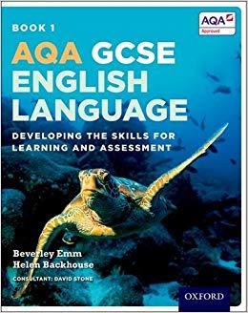  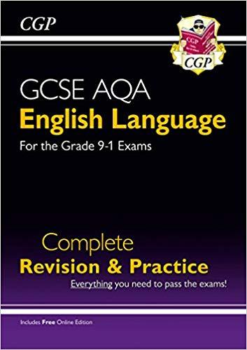 | Revision Guides:  - CGP English Language for Grade 9-1 Exams  - AQA GCSE English Language: Student Book: Developing the skills for Learning and Assessment (Oxford)  - Revise AQA GCSE (9-1) English Language Practice Papers (Pearson)

Paper 1: Explorations in Creative Reading and Writing (fiction extract)
Focus | Question | Requirement | Marks | Timing | Sources
Reading time 5 minutes
Reading | 1 | Four things you learn | 4 | 5 | Source A  (opening)
Reading | 2 | Language analysis | 8 | 10 | Source A  (extract)
Reading | 3 | Structure | 8 | 10 | Source A  (whole text)
Reading | 4 | Language analysis/ evaluates | 20 | 30 | Source A  (second ½ of extract)
Writing | 5 | Describe: picture | 24: content  16: SPaG | 45 min | N/A

Paper 2: Writer’s Viewpoints and Perspectives (non-fiction extracts A&B)
Focus | Question | Requirement | Marks | Timing | Sources
Reading | 1 | Four things you learn | 4 | 5 | Source A (opening)
Reading | Reading Time 5 minutes
Reading | 2 | Summarise differences with quotes | 8 | 15 (reading time inc) | Source A and Source B
Reading | 3 | Language analysis | 12 | 15 | Source B
Reading | 4 | Compare language | 16 | 20 | Source A and Source B
Writing | 5 | Argue or persuade | 24: content  16: SPaG | 45 min | N/A

Reading Exam Top Tips | Writing Exam Top Tips
- The exam requires students to read and respond to short texts very quickly  - Reading a range of texts – not necessarily novels – will help students to grow more confident with reading short texts  - The exam requires students to answer a range of questions with a very limited amount of time  - Knowing the specific requirements of each question and how long they have to complete their response is crucial to their success  - The difficulty many students face with the English Language exam is the time restraints  - Practicing reading short texts and planning responses to these texts will help students grow more confident when approaching the exam. | - Whereas the reading part of the GCSE English Language exam has its challenges, the writing part of the exam is worth 50% and offers students the opportunity gain valuable marks  - Students can use resources such as Knowledge Organisers to practice writing in form (newspaper/ letter/ blog) and purpose (argue, persuade/ explain)  Spelling, Punctuation and Grammar (SpaG)  - Students should revise punctuation: particularly colons and semi colons. YouTube is a great resource for this.  - Students can revise frequently misspelt words  - Write responses based on past paper questions (see AQA website) or in response to articles they have read  - Students should look to imitate things they read: they are demonstrating skill and not necessarily originality

AQA GCSE English Literature (8702)

English Literature Unit 1:  Shakespeare and the 19th Century Novel | English Literature Unit 2:  Modern texts and poetry
1 hour 30 minutes  13th May 2024  External Exam: Worth 40% of the final GCSE English Language grade  Section A: Shakespeare  - One question on the play studied (Macbeth). Students will be required to write in detail about an extract from the play and the play as a whole.  Section B: 19th Century Novel  - One question on A Christmas Carol. Students will be required to write in detail about an extract from the novel and then the novel as a whole. | 2 hours 15 minutes  20th May 2024  External Exam: Worth 60% of the final GCSE English Language grade  Section A: Modern Texts  - Students will answer one essay question on An Inspector Calls  Section B: Comparative Poetry  - Students will answer one question which asks them to compare two poems. One poem will be printed: the other will not.  Section C: Unseen Poetry  - Students answer one question on an unseen poem followed by another question asking them to compare this to a second unseen poem.

English Literature Mock Exam Dates

- English Literature Paper 1: January Mocks
- English Literature Paper 2 (excluding Anthology Poetry) : January Mocks

Free online resources:  There are a wide range of English Literature resources available online  - Spark Notes  - Spark Notes: No Fear Shakespeare  - GCSE Bitesize  - LitCharts  - Schmoop  - Universal Teacher  - Mr Bruff (YouTube) |   
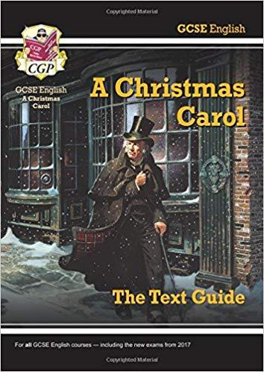  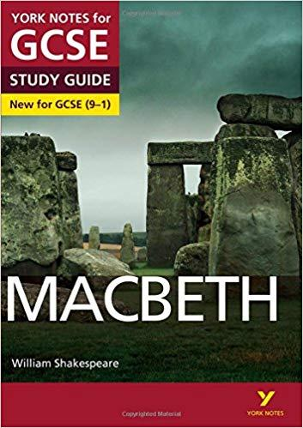 | Revision Guides:  - CGP English Revision Guides  - York Notes

Paper 1: Shakespeare and the 19th century novel
Focus | Question | Requirement | Marks | Timing | Sources
Section A: Shakespeare  Macbeth | 1 | - Explore the focus of the extract analysing the language  - Explore the focus of the extract elsewhere in the play | 30 marks  + 4 SPaG | 52 min | Extract  Remembered quotes from elsewhere in the play
Section B:  19th Century novel  A Christmas Carol | 7 | - Explore the focus of the extract analysing the language  - Explore the focus of the extract elsewhere in the play | 30 marks | 52 min | Extract  Remembered quotes from elsewhere in the novel

Paper 2: Modern texts and poetry
Focus | Question | Requirement | Marks | Timing | Sources
Section A: An Inspector Calls | 1 or 2 | Essay style answer exploring theme, character or dramatic devices | 30 marks  + 4 SPaG | 45 min | CLOSED TEXT
Section B: Poetry (Power and Conflict) | 26 | Compare language used in two poems from the anthology | 30 marks | 45 min | CLOSED TEXT  One poem will be reprinted in exam, one will not
Section C: Unseen | 27.1 | Language analysis of unseen poem | 24 | 30 min | Poem printed in exam
Section C: Unseen | 27.2 | Compare similarities and differences in unseen poems | 8 | 15 min | Poem printed in the exam

Revision Tips
- The exam requires students to complete the exam WITHOUT copies of the text which requires them to learn quotations
- Students should re-read the exam texts to re-familiarize themselves with the texts: re-reading the texts is not revision
- Return to texts sooner rather than later and then return to them again rather than ‘cram’
- Students should look to learn quotations rather than try to remember whole sections of texts or even whole poems
- Students should begin revision by identifying the ten most important quotations for key characters and themes: before long it will become apparent that valuable quotations reappear over and over
- Create flash cards or mind-maps of key quotations linked to themes: these can be used for making links across texts/ between poems
- Plan responses to a range of questions rather than write whole answers: this helps you to revise whole texts rather than practice limited responses

